Alarm O’Clock

Andrew Apostol

CS 122A Fall 2017

**Phase I** **2**

Introduction 2

Components (Pin-out) 2

70 - 80 points project 3

80 - 90 points project 3

90 - 100 points project 3

**Phase II** **4**

Milestone 4

Testing and Verification 4

Form Factor 4

# Phase I

## Introduction

Last Christmas, my older sister’s boyfriend bought me a raspberry pi kit. I was thinking of different projects that I could do with it, and I wanted to make him something that he could use in his room. I had come across some adafruit matrix LEDs while researching my CS120B project and wanted to incorporate them in the project.

The project is an alarm clock that can tell the time, day of week, date, and weather, and set off an alarm. All settings except for the weather can be set by user input. The weather is taken from a sensor that communicates serially. Ideally, the clock is set next to a window while the sensor is outside the window and communicates through bluetooth. The alarm is turned off by the heartbeat sensor sensing a heartbeat. Once the alarm is turned off, an assigned radio station will play.

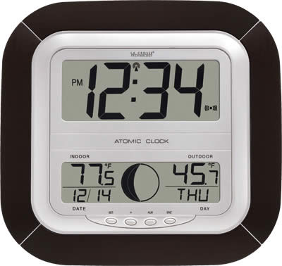

## Components (Pin-out)

* **Inputs**
  + Joystick A0
  + 2 Buttons A2, A3
  + Heartbeat sensor A4
  + DS3231 SDA C1
  + RXD0 (to Arduino) D0
* **Outputs**
  + Shift Register D0-D4
  + LCD Display D5-D6
  + TXD1 (to Arduino) D1
  + DS3231 SCL C0
* **Internal components**
  + Serial component between Atmega1284p and DS3231
  + Heartbeat sensor ADC
  + USART between Atmega1284p and Arduino Uno
  + TEA5767 Low power FM Stereo Radio
* **Microcontrollers/Processors**
  + Atmega1284p
  + Arduino Uno
    - There are libraries that support reading from TEA5767
    - I have some experience working with Arduino Uno
    - I know some people who have worked with Arduino before

Include a block diagram on how all of the components will be connected. Include:

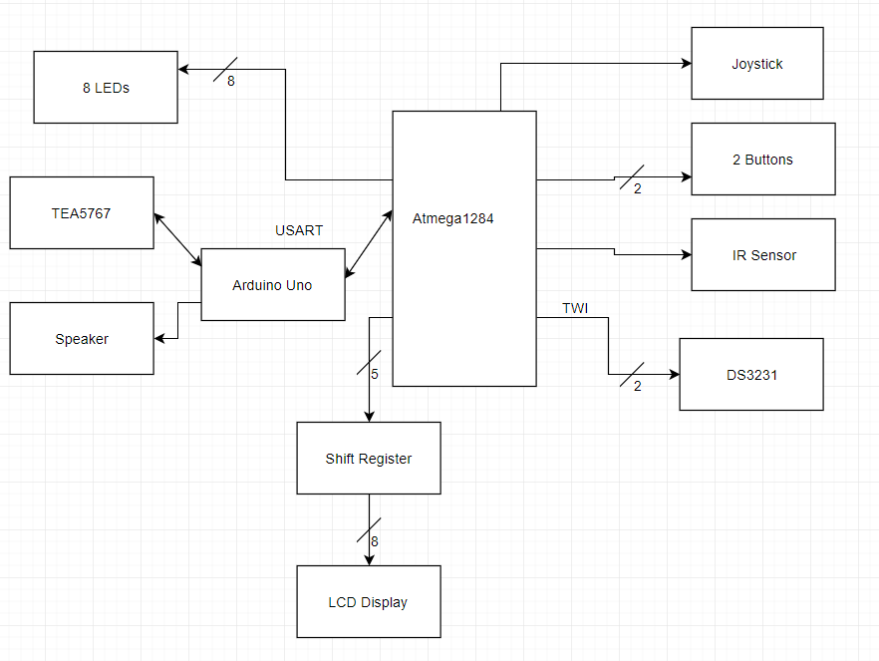

## 70 - 80 points project

Gather input (time, day, date) from DS3231.

Gather input from temperature sensor.

Output input data and temperature onto the LCD Display.

Programmable alarm.

Gather input from heartbeat sensor.

## 80 - 90 points project

FM Radio on the Arduino Uno connected to the Atmega1284p through USART. This adds engineering complexity through communicating between two microcontrollers and listening to the radio.

## 90 - 100 points project

I am okay with the current project.

# Phase II

## Milestone

**What** is your target milestone? **When** is your intended milestone date (non-binding).

Every week I want to finish one part of the 70-80 point project.  
Week 1: Read from LCD Display and gather input from temperature sensor.

Week 2: Gather input from DS3231 and display on LCD Display.

Week 3: Program the alarm, buttons, and joystick.

Week 4: Gather input from the heartbeat sensor and set it to turn off the alarm

I want to demo the 70-80 points project by Monday November 27th.

Week 5: Program FM radio on Arduino Uno and connect to Atmega1284p through USART.

Week 6: Project cleanup and final demo

## Testing and Verification

The 70-80 point project will be tested by fellow 122A students. They will input alarms and cancel the alarms using their heartbeats. The alarm can be tested week 3 with a button. The heartbeat will be tested week 4 with an LED. Once both are functioning correctly, they will be combined and tested together using the DS3231 as a clock.

The 80-90 point project will be tested by other engineering majors who are part of SWE.

They will test the alarm once more. The radio should turn on when the alarm turns off.

**What** is your plan to test your invention? **How** will you test each “point level” in your project? **When** will you start testing each stage. Specifically what do you plan to do to test each stage, and who are you going to have test each stage? This doesn’t need to be the name of a person, but more a general who. For example:

* 70 - 80 point project
  + Tested by my lab partner from earlier 122A labs
  + Tested by my roommate/friend from CS 120B
* 80 - 90 point project
  + Tested by a friend from IEEE that hasn’t taken 120B
* 90 - 100 point project
  + Tested by roommate in the a different major (what major)

If you notice the testers get more general as your project gets more mature. Engineers tend to have a better grasp of what these inventions are supposed to do, and are less likely to put in incorrect input. General majors are more likely to interact in a way that will illuminate bugs.

## Form Factor

This is the non-engineering portion of the proposal/project. **IF** you were to make a case for your project, embed it in the environment, or “deploy” it in some fashion. What would that look like? Would you need to shrink the form factor down before deployment? Could you 3D print a case? Could you build one from wood?

**NOTE:** This is not required for this course, but presentation is still important, and it is something to think about doing before you take a project into an interview.